Part A Report

Name: Xinyi Yang (replace with your own name and delete this instruction!)

Assignment 6: Perceptron Classification and Training

CSE 415 Introduction to Artificial Intelligence, Winter 2021, University of Washington

Please answer each question using text in Blue, so your answers stand out from the questions.

QA1. How many epochs were required to train your perceptron on the 2-class Iris data having 2 features?

4

QA2. Include a graphic produced using matplotlib that shows both the training data points (in separate colors) and the “separating” lines implied by the weights at the end of each training epoch.” (Reduce the graphic as necessary to make it fit here without taking up more than half the page.)

Was there any thrashing (oscillation in the separator, such as flipping slope back and forth between positive and negative values, or having its y intercept jumping up and down as epochs proceed? How would you describe the progress of the learning, on the basis of the plot?

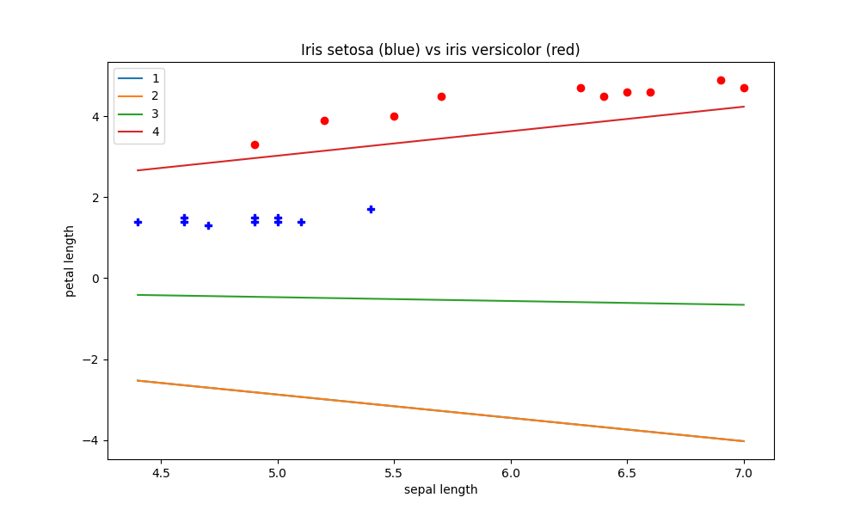

Yes, the first line is not shown in the plot. The second line has a negative slope. Then the third becomes almost horizontal. Finally, the fourth one has a positive slope. All the lines are smooth. The line gets closer to the points as the iteration goes and finally lies in the middle of the two areas contain different colors of points, separating the two clusters.

QA3. What was the performance of your perceptron on the test data?

Performance ...

(a) total number of test examples: 4

(b) number of examples correctly classified. 4

(c) [b] as a percentage of [a]: 100%

(d) number of examples misclassified: 0

(e) [d] as a percentage of [a]: 0%

QA4. After plotting the ring data, describe its distribution in words.

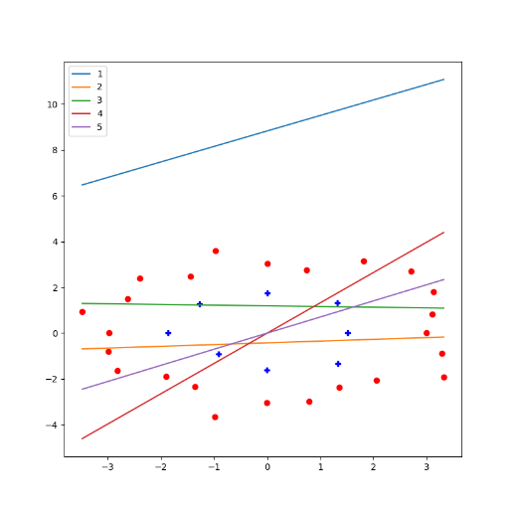

There are two groups of dots forming two circles. The blue dots are surrounded by the red dots.

QA5. Describe the sequence of separators obtained when training your perceptron for 5 epochs using the ring data. To what extent is there convergence? Thrashing? Hope for convergence?

It clearly does not converge. And I don’t think it can converge. If there is a line that can perfectly separate the two groups of dots, it would a curve or a circle rather than a straight line. The first line is far away from the target data, and it has a positive slope. Then it is nearly horizontal and lies in the middle of the area where the data is plotted. It goes up and down, and the slope becomes larger and then smaller after the next several iterations.

QA6. After you have re-mapped the ring data with the provided non-linear mapping function, plot the data and describe the distribution.

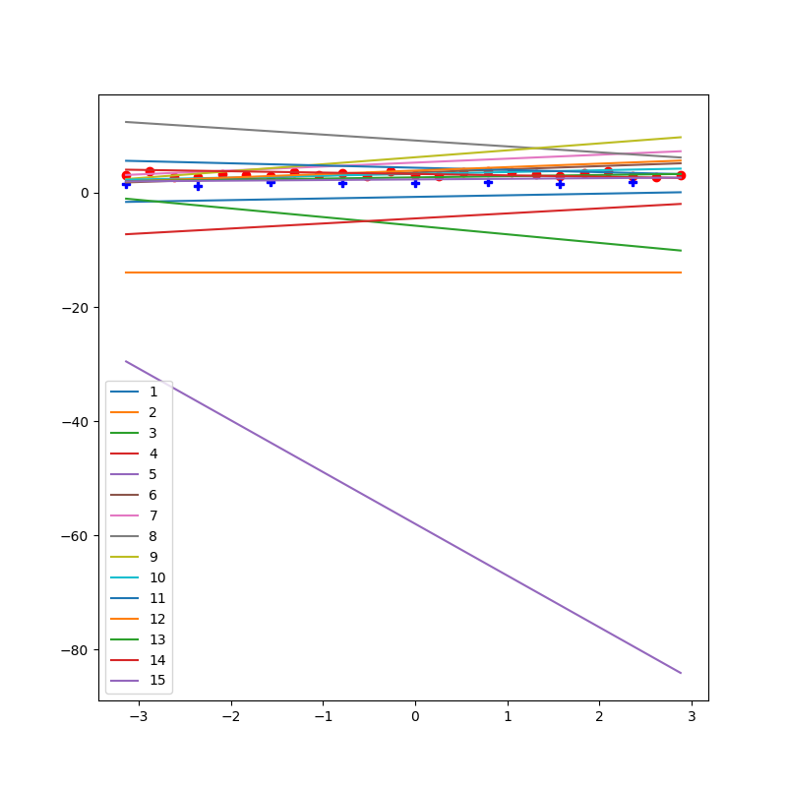

The two groups of data seem to be approximately horizontal this time. They are very close to each other.

QA7. After training your perceptron on the re-mapped ring data, did it achieve convergence, and if so, how many epochs were used?

It did not. I actually increased the number of epochs to 20 and I observed that it converges at 15.

QA8. What does these results suggest about the power of perceptrons to classify data that may consist of clusters that cannot be separated by a linear manifold (such as a line or plane)?

We might need other non-linear methods to compute the weighted sum rather than this linear method by multiplying the weights and Xs and sum them up.

QA9. Did you run into any difficulties either setting up for Part A or running the programs and answering the questions? If so, please describe them.

I was confused which to run and which plot the question refers to. And I’m also not sure whether my code is correct although I got the plots printed out.

And if we can have more detailed legend or instructions on the plot to identify what is what, that would be much easier to read the plots.

QA10. What portion(s) of Part A did you find most worthwhile and why?

To observe how the algorithm learns to achieve the goal.